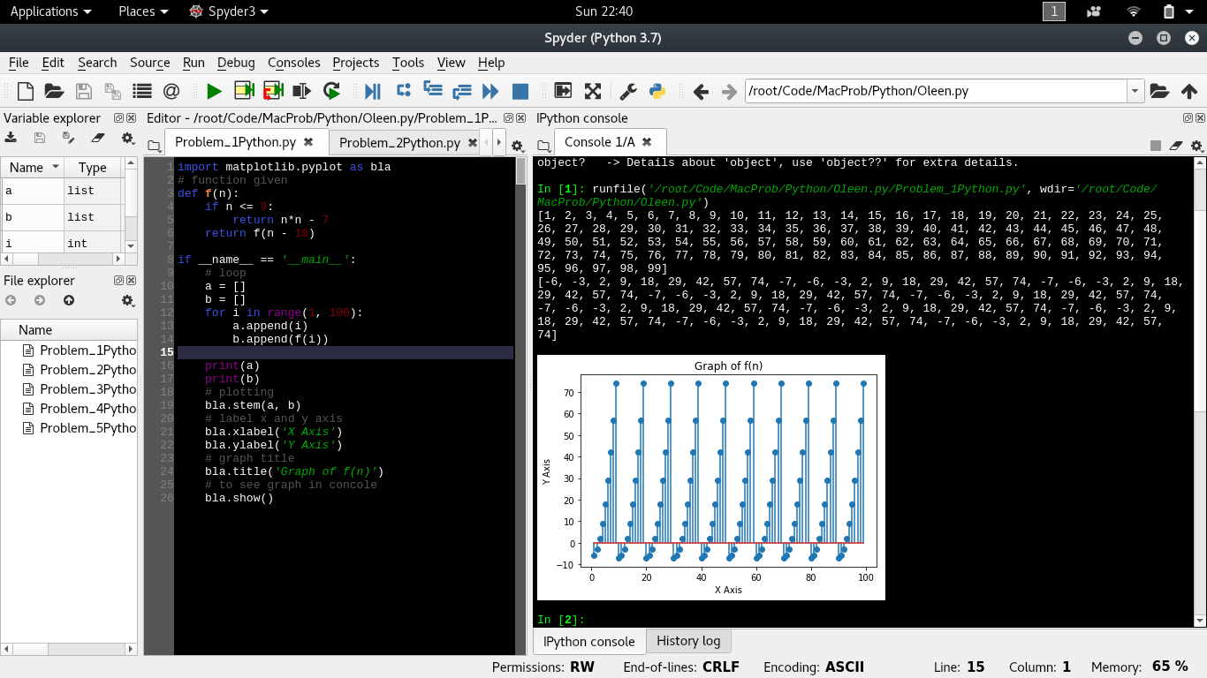Problem 1

Problem 2

Positive Testing(unit circle)

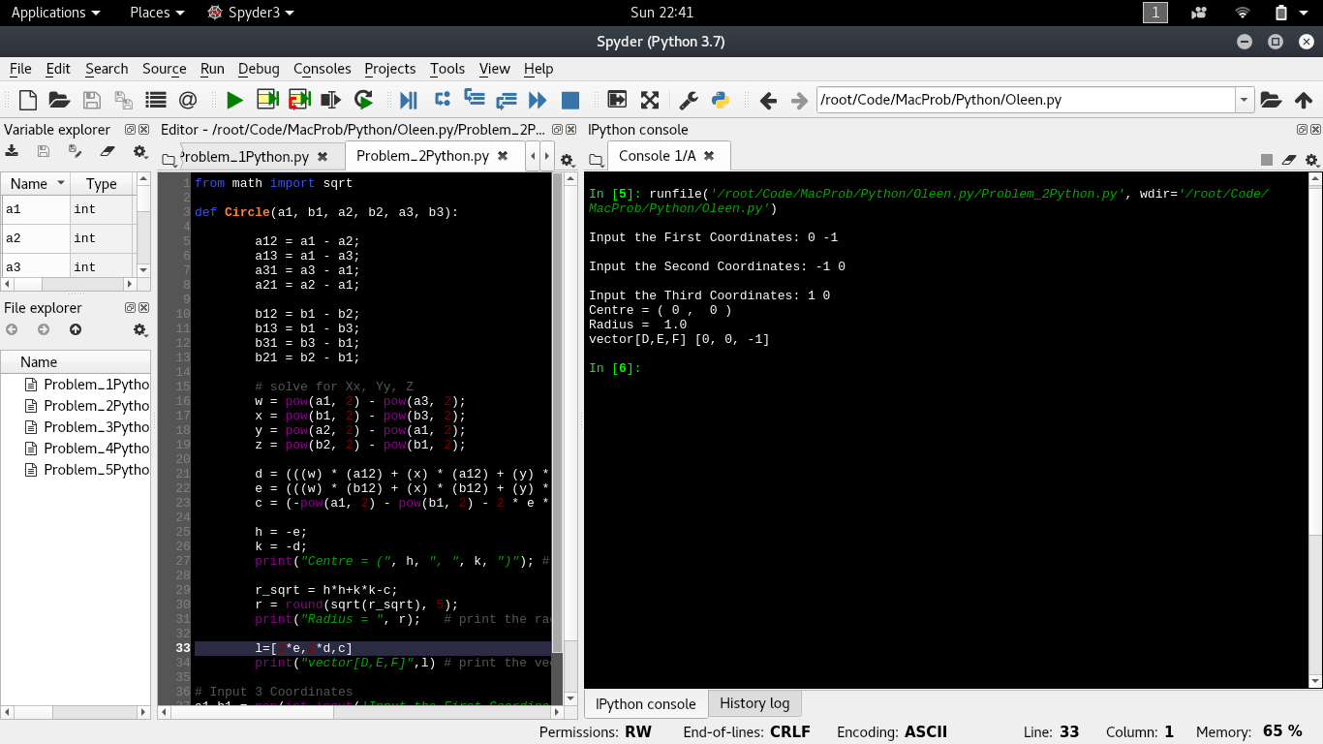

Negative testing (point not on the same circle)

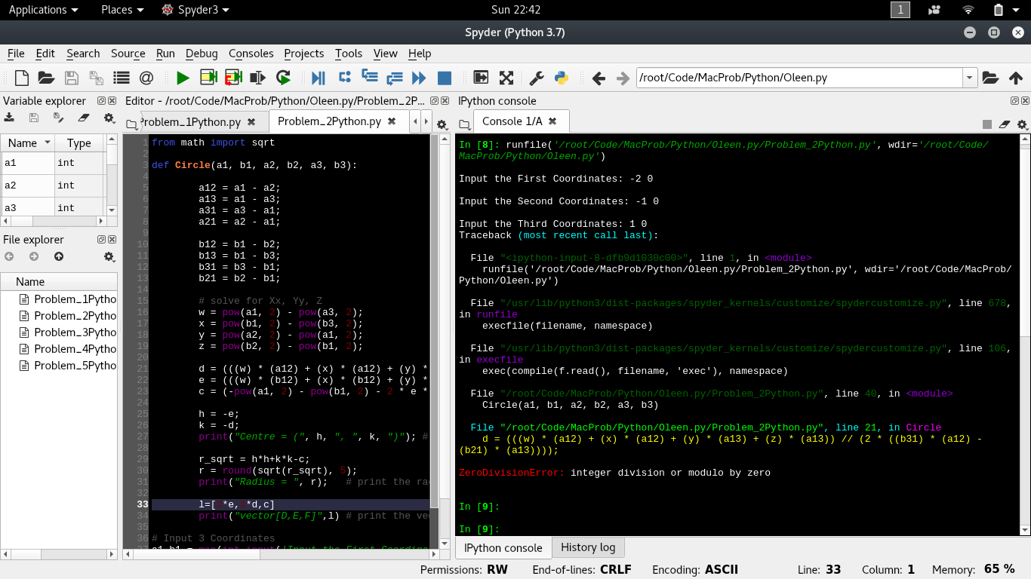Problem 3

Positive Testing(x=1:5 , y = 6:10)

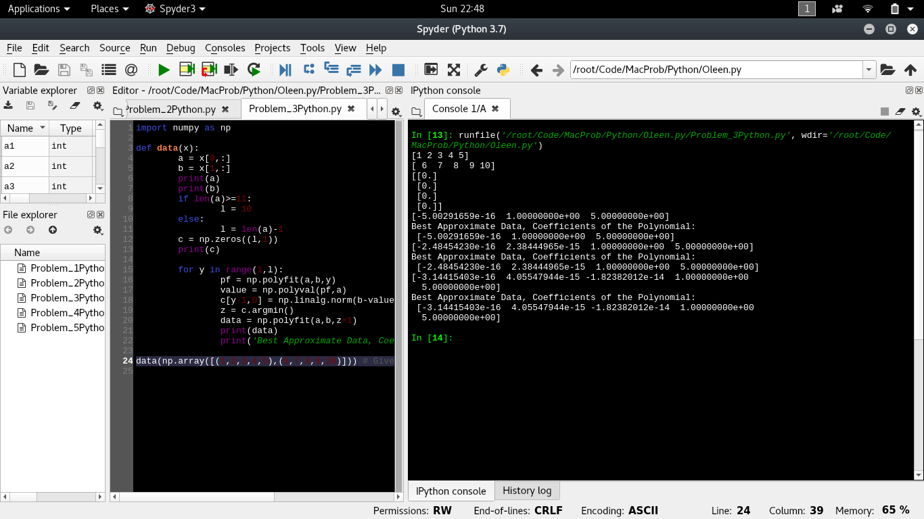

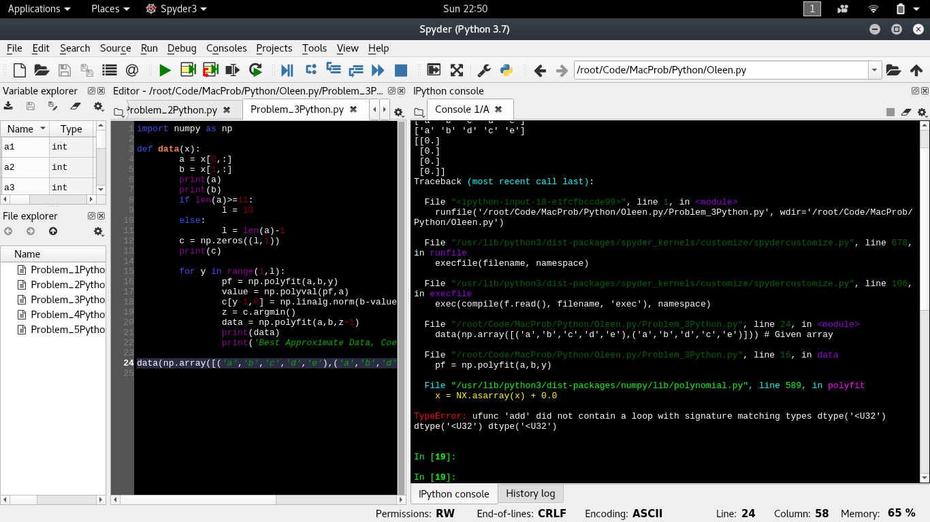Negative Testing (letters)

Problem 4 ( hi = 60 mag =60 theta =60 ax = 0 ay = -9.8)

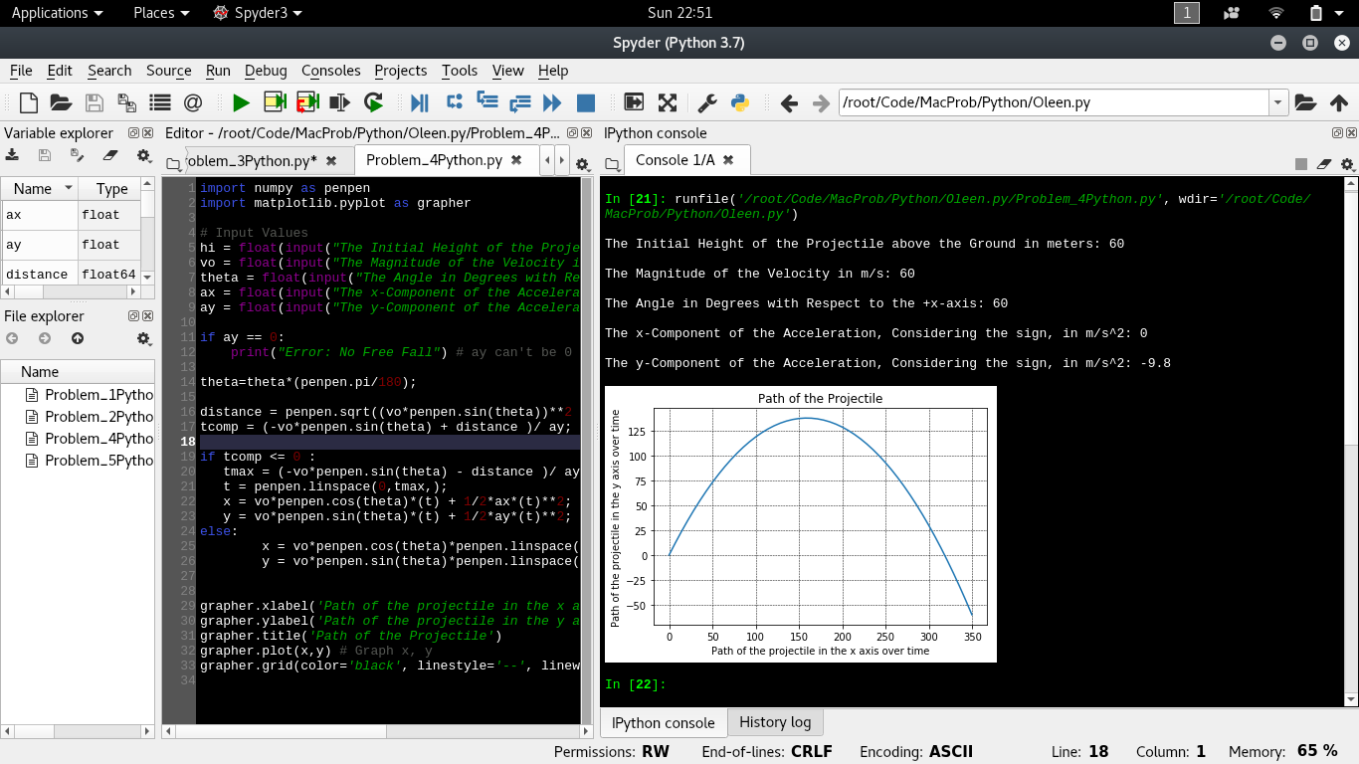

Negative Testing(Ay = 0)

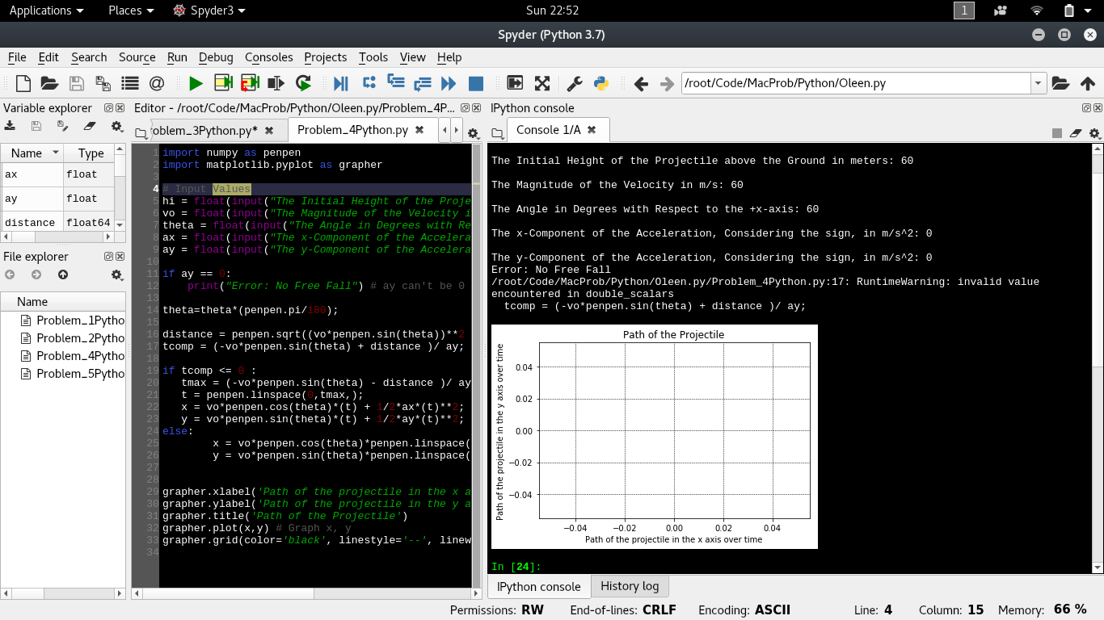

Problem 5

